

**SP22 CNN221L NETWORKING II**

**VLSM**

**Prepared by**: Ralph El Sayegh

**Presented to**: DR Khaled Zein

**Semester** : Spring 2021/2022

Table of Contents

I. Introduction: 4

II. VLSM Project . 4

A. Given: 4

B. Solve the problem starting with VLSM : 5

C. Router configuration: 6

D. Switch Configuration 8

E. Testing the project 9

III. Conclusion 12

# Introduction:

What is VLSM:

Variable Length Subnet Mask (VLSM) is a subnet design strategy where all subnet masks can have varying sizes. This process of "subnetting subnets" enables network engineers to use multiple masks for different subnets of a single class A, B or C network.

With VLSM, an IP address space can be divided into a well-defined hierarchy of subnets with different sizes. This helps enhance the usability of subnets because subnets can include masks of varying sizes.

A subnet mask helps define the size of the subnet and create subnets with very different host counts without wasting large numbers of addresses.

# VLSM Project .

## Given:

## https://lh3.googleusercontent.com/idyMTDbYRPoycbSVSWsQqkgB5z7zwwzVRB-MJZbGWMNBvpk8dZpMLMB8kbOYed6YhnErurFy42Dt9ZWbZUSL5-JyqBwWxwD1JjW-Q4JjYt5Dh-KLdCHk0yQ1oq2J-8Z576aqIFMXtVz4pR3VJA

Provided with the Network 192.168.10.0/24, the company is composed of two  departments:

1) Human Resources department: 25 hosts

2) Accounting department: 55 hosts

In order to prevent IP loss, we will subnet the network  using **VLSM** subnetting.

## Solve the problem starting with VLSM :

## network :192.168.10.0/24

## 1- accounting department : 55 hosts

## 2 to power n = > 55

## 2 to power 6 = 64

## 6 remaining and 2 borrowed class C : 255.255.255.0

## network ip= 192.168.10.0 (borrowed)/( remaining )

## 255.255.255. 2^7 + 2^6 + 2^5 + 2^4 + 2^3 + 2^2 + 2^1 + 2^0

## 128 + 64 + 32 + 16 + 8 + 4 + 2 + 1

## broadcast:192.168.10.63(we add the remaining)

## subnet mask: 255.255.255.192(we add the borrowed) 128+64=192

## cidr value:/26( we add the non remaining part)

## .......................................................................................................................

## 2-HRD : 25 host

## 2 to power n = > 25

## 2 to power 5 = 32

## 5 remaining and 3 borrowed

## network ip:192.168.10.64

## (borrowed )/( remaining )

## 255.255.255. 2^7 + 2^6 + 2^5 + 2^4 + 2^3 + 2^2 + 2^1 + 2^0

## 128 + 64 + 32 + 16 + 8 + 4 + 2 + 1

## broadcast: 192.168.10.95(we add the remaining)

## subnet mask: 255.255.255.224

## cidr value:/27

## Router configuration:

**Router>enable**

**Router#conf t**

**Enter configuration commands, one per line. End with CNTL/Z.**

**Router(config)#hostname RA**

**RA(config)#enable password 11111**

**RA(config)#enable secret 22222**

**RA(config)#banner motd #unauthorized access to this device is prohibited!#**

**RA(config)#line con 0**

**RA(config-line)#password 33333**

**RA(config-line)#login**

**RA(config-line)#exit**

**RA(config)#line vty 0 4**

**RA(config-line)#password 44444**

**RA(config-line)#login**

**RA(config-line)#exit**

**RA(config)#int fa0/0**

**RA(config-if)#ip address 192.168.10.65 255.255.255.224**

**RA(config-if)#no shut**

**%LINK-5-CHANGED: Interface FastEthernet0/0, changed state to up**

**%LINEPROTO-5-UPDOWN: Line protocol on Interface FastEthernet0/0, changed state to up**

**RA(config-if)#**

**RA(config-if)#no shut**

**RA(config-if)#exit**

**RA(config)#int fa 0/1**

**RA(config-if)#ip address 192.168.10.1 255.255.255.192**

**RA(config-if)#no shut**

**%LINK-5-CHANGED: Interface FastEthernet0/1, changed state to up**

**%LINEPROTO-5-UPDOWN: Line protocol on Interface FastEthernet0/1, changed state to up**

**RA(config-if)#no shut**

**RA(config-if)#exit**

**RA(config)#service password-encryption**

**RA(config)#exit**

## Switch Configuration

**1)Switch SA :**

**Switch>enable**

**Switch#conf t**

**Enter configuration commands, one per line. End with CNTL/Z.**

**Switch(config)#hostname SA**

**SA(config)#enable secret 11111**

**SA(config)#line con 0**

**SA(config-line)#password 22222**

**SA(config-line)#login**

**SA(config-line)#exit**

**SA(config)#int vlan1**

**SA(config-if)#ip address 192.168.10.94 255.255.255.224**

**SA(config-if)#no shut**

**%LINK-5-CHANGED: Interface Vlan1, changed state to up**

**SA(config-if)#**

**%LINEPROTO-5-UPDOWN: Line protocol on Interface Vlan1, changed state to up**

**SA(config-if)#no shut**

**SA(config-if)#exit**

**SA(config)#ip default-gateway 192.168.10.65**

**SA(config)#line vty 0 15**

**SA(config-line)#password 33333**

**SA(config-line)#login**

**SA(config-line)#exit**

**SA(config)#exit**

**2)Switch SB:**

**Switch>enable**

**Switch#conf t**

**Enter configuration commands, one per line. End with CNTL/Z.**

**Switch(config)#hostname SB**

**SB(config)#enable secret 11111**

**SB(config)#line con 0**

**SB(config-line)#password 22222**

**SB(config-line)#login**

**SB(config-line)#no shut**

**^**

**% Invalid input detected at '^' marker.**

**SB(config-line)#exit**

**SB(config)#int vlan1**

**SB(config-if)#ip address 192.168.10.62 255.255.255.192**

**SB(config-if)#no shut**

**%LINK-5-CHANGED: Interface Vlan1, changed state to up**

**%LINEPROTO-5-UPDOWN: Line protocol on Interface Vlan1, changed state to up**

**SB(config-if)#no shut**

**SB(config-if)#exit**

**SB(config)#ip default-gateway 192.168.10.1**

**SB(config)#line vty 0 15**

**SB(config-line)#password 33333**

**SB(config-line)#login**

**SB(config-line)#exit**

**SB(config)#exit**

## Testing the project

## From pc B to C then From pc B to D

## 

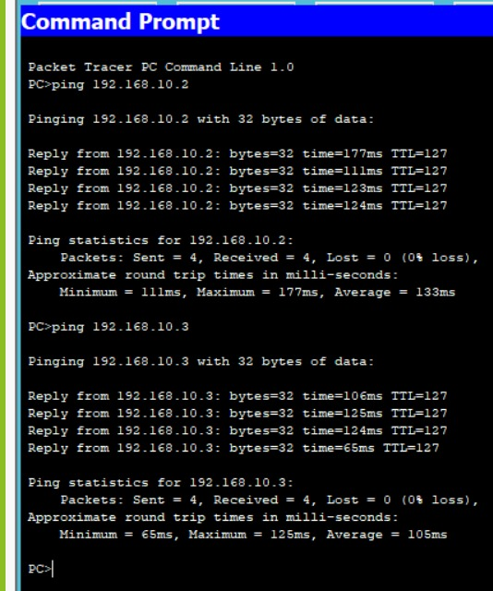

## From pc A to D then From pc A to C :

## C:\Users\user\AppData\Local\Microsoft\Windows\INetCache\Content.Word\WhatsApp Image 2022-06-16 at 12.25.39 PM (1).jpeg

## C:\Users\user\AppData\Local\Microsoft\Windows\INetCache\Content.Word\WhatsApp Image 2022-06-16 at 12.25.39 PM (2).jpeg

## 

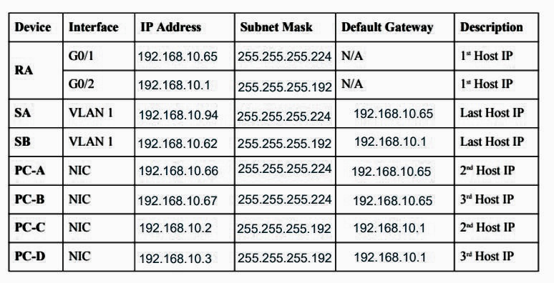

# Conclusion

In the end Variable Length Subnet Mask (VLSM) was designed to avoid wasting IP addresses. With VLSM, a network is submitted and then re-submitted. This process can be repeated multiple times to create subnets of various sizes based on the number of hosts required in each subnet